Group Assignment

TBA 5150 Geohazards and Risk Analysis

October 25, 2023

**Before you start (Must read!!!!!!!!!!!):**

* Please do every question by yourself even if you are in a group. You’ll know why when you take the final exam.
* You are strongly encouraged to do coding from scratch, programming language can be python, matlab, etc. You can even use Excel if you know how to do that. By saying coding from scratch, I mean you try to use some more basic functions to realize each specific step of FOSM, FORM, instead of calling the FOSM/FORM functions as a black-box function.
* At the end, you’ll submit a report to briefly explain your results. You’ll also make a presentation in Week 47 (Nov. 21). The presentation will be evaluated. You’ll also have feedbacks then.

1. Problem definition

Yutao is having his holiday in Singapore and he drove the whole family to Oslo airport earlier. While he is enjoying the summer, he finds from NRK that the storm Hans is going to hit Norway, as predicted by the weather forecast, which may lead to floods and landslides. He is going to fly back to Oslo in two days. His original plan is to drive the whole family back home from Oslo airport. However, it is expected that some landslides along the routes may block the road.

He has to make a decision quickly, because the later he makes the decision, the more the expense (price of air ticket in Norway will soon increase). Until now, no landslides have happened along the way yet. It is known that 7 landslides-prone areas were along the three possible routes, as shown in Figure 1b. Now he would like to estimate the failure probability and make informed decisions:

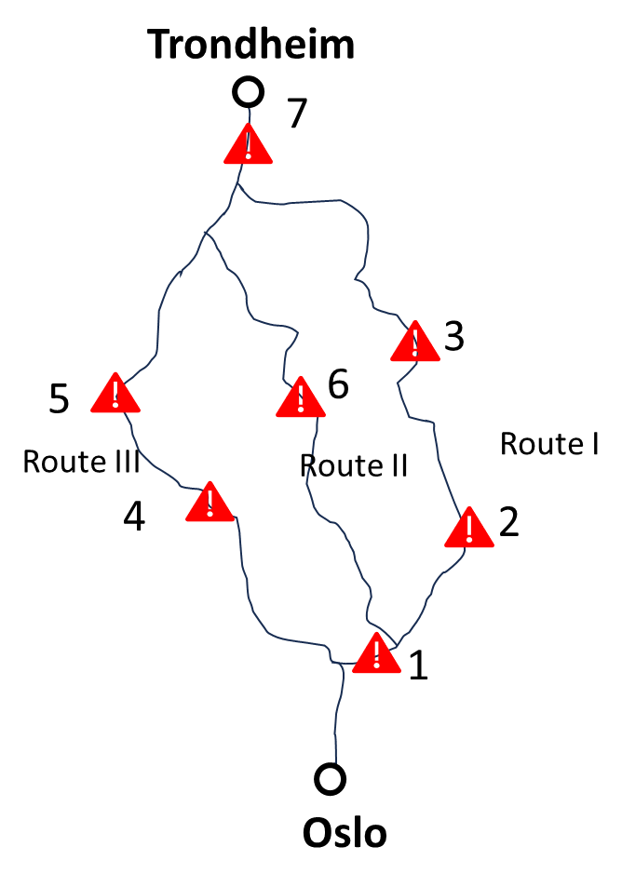

Figure 1: Problem definition.

1. **Assignment**

**2.1 Question 1**

The factor of safety for a circular slope failure is defined as:

$F= \frac{S_{u}L R}{W X+qle}$ (1)

where ***F*** is the factor of safety, ***S*u** the undrained shear strength, ***R*** the radius of the slip surface, ***L*** the length of slip surface, ($L=αR$, $α$ is the center angle of the slope (unit: rad), as shown in Figure 2), ***W*** the weight of the soil mass resting above the slip surface, $W=\frac{1}{2}{γR}^{2}(α-sinα)$, $γ$ is the unit weight of soil and note that $α$’s unit is rad, not degree; ***X*** is the moment arm of ***W*** w.r.t. to the center of slip surface $X=\frac{1}{2}Rsinα$, ***q*** is the vertical loading acting on the slope. ***l*** is the width of distributed loading in the failure zone $l=ηR$, $η$ is a conefficient between loading width and the diameter $R$. and $e$ is the moment arm of ***q*** wrt to the center of the slip surface $e=Rsinα$. This gives the complete formulation of FOS:

$F= \frac{S_{u}α}{\frac{1}{4}γR(α-sinα)sinα+ηqsinα}$ (2)

The model error $ε$ should also be considered:

$F= \frac{εS_{u}α}{\frac{1}{4}γR(α-sinα)sinα+ηqsinα}$ (3)

He does not have the distribution of all variables, but he does have previous years data in the data2023.txt. Table 1 shows the statistical features of parameters. We still lack information of undrained shear strength $S_{u}$ and unit weight $γ$. He needs to look at the dataset (data2023.txt) to figure out the features. We only have 5 measurements of unit weight from coring samples for each zone. For undrained shear strength *s*u, we have one CPT data near the slope top. The sampling interval is 2 cm. The interpreted *s*u along depth is given in the txt file. Statistical features of all other parameters are given in Table 1.

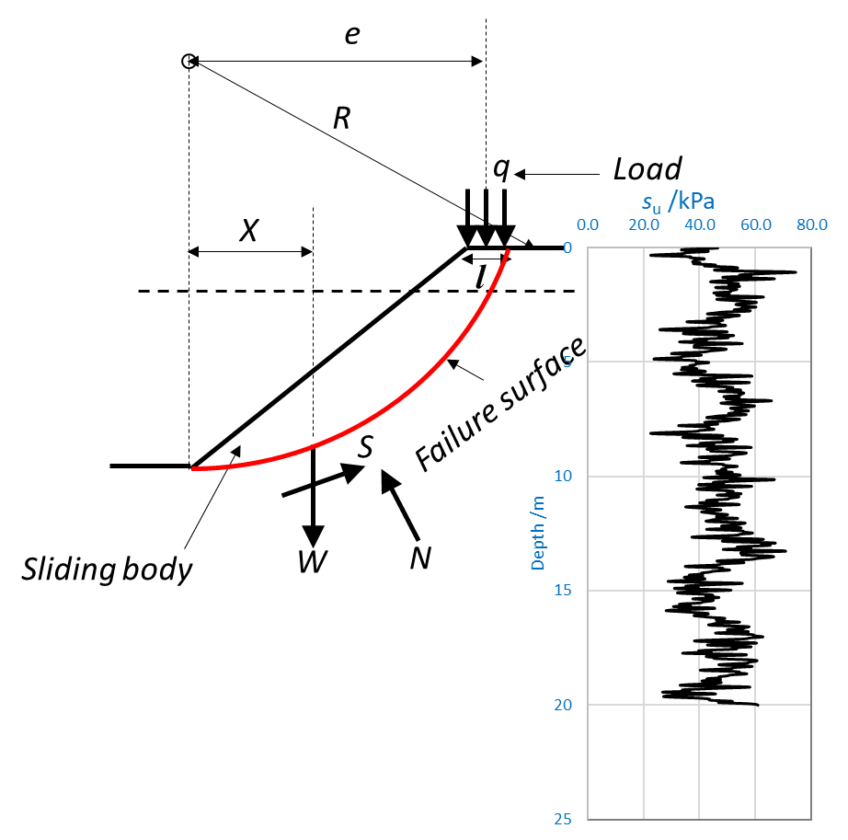

Figure 2 Circular slope failure

* Extract the statistical values in datasets and comment on the statistical features (possible probability distribution using q-q plots, sample mean and sample variance).

Table 1: Random parameters in the infinite slope model in Eq. 3

|  |  |  |  |  |  |  |  |  |  |
| --- | --- | --- | --- | --- | --- | --- | --- | --- | --- |
| Rand. Var. | Dist. | Par. | Zone 1 | Zone 2 | Zone 3 | Zone 4 | Zone 5 | Zone 6 | Zone 7 |
| $$ϵ$$ | N | $$μ_{ϵ}$$ | 1 | 1 | 1 | 1 | 1 | 1 | 1 |
| $$σ_{ϵ}$$ | 0.1 | 0.1 | 0.1 | 0.1 | 0.1 | 0.1 | 0.1 |
| $s_{u}$ Unit(kPa) | ? | $$μ_{s_{u}}$$ | ? | ? | ? | ? | ? | ? | ? |
| $$σ_{s_{u}}$$ | ? | ? | ? | ? | ? | ? | ? |
| $$α$$**Unit ($°$)** | N | $$μ_{α}$$ | 60 | 60 | 60 | 60 | 60 | 60 | 60 |
| $$σ_{α}$$ | 9 | 9 | 9 | 9 | 9 | 9 | 9 |
| $$γ$$ | ? | $$μ_{γ}$$ | ? | ? | ? | ? | ? | ? | ? |
| $$σ_{γ}$$ | ? | ? | ? | ? | ? | ? | ? |
| $$R$$ Unit(m) | N | $$μ_{R}$$ | 8 | 8 | 8 | 8 | 8 | 8 | 8 |
| $$σ_{R}$$ | 1.6 | 1.6 | 1.6 | 1.6 | 1.6 | 1.6 | 1.6 |
| $$η$$ | N | $$μ_{η}$$ | 0.1 | 0.1 | 0.1 | 0.1 | 0.1 | 0.1 | 0.1 |
| $$σ_{η}$$ | 0.01 | 0.01 | 0.01 | 0.01 | 0.01 | 0.01 | 0.01 |
| $$q$$ Unit(kPa) | N | $$μ_{q}$$ | 10 | 10 | 10 | 10 | 10 | 10 | 10 |
| $$σ_{q}$$ | 2 | 2 | 2 | 2 | 2 | 2 | 2 |

**2.2 Problem 2**

* Calculate mean and standard deviation of $F_{S}$ for all critical zones using First Order Second Moment (FOSM) method.
* Conceive a performance function g, and calculate failure probabilities for all zones, **state your assumptions here**.

**2.3 Problem 3**

* Calculate failure probabilities and reliability indexes for all zones using First Order Reliability Method (FORM) with convergence rate on the reliability index lower or equal to $ϵ_{β}$ = 0.001.
* Calculate and present sensitivity coefficients for random parameters for all critical zones.

**2.4 Problem 4**

* **Validate** your codes with a linear combination of all parameters.
* Calculate failure probabilities for all zones using Monte Carlo (MC) method with $CoV\left(P_{F}\right)≤0.1$ or maximum number of simulation.
* Compare the failure probabilities calculated with FOSM, FORM and MC method.
* Comment on the efficiency and accuracy of all methods.
* Evaluate the response of the MC simulation in terms of $F_{S}$. Calculate mean, standard deviation and empirical pdf of $F_{S}$ as a histogram. Compare the mean and standard deviation of $F_{S}$ to the values calculated by the FOSM method in Problem 1.

**2.5 Problem 5**

* Define minimal cut set corresponding to systems representing a connection between Oslo and Trondheim through the three routes.
* Calculate system failure probabilities using minimal cut set representation for the three alternative positions of the planned railway assuming that failure events in Zones 1 to 7 are mutually independent. Compare system failure probabilities (probability that one cannot reach Trondheim by driving through the three routes) calculated with FORM and MC estimates of Zones 1 to 7 failure probabilities.
* Evaluate system failure probabilities with Event Trees. Build event trees given that the initiating event of the ground water level rise had occurred. Calculate system failure probabilities assuming that failure events in Zones 1 to 7 are mutually independent. Compare system failure probabilities calculated with FORM and MC estimates of Zones 1 to 7 failure probabilities.

**2.6 Problem 6**

Now it is time for Yutao to make a decision. He wants to know which decision potentially has the lowest expected cost. Please note that when he drives, he has to bet on one route

* + If he can drive back to Trondheim without being stopped by any of the potential slope failures on the chosen road, then the expense is $C_{0}=1200 kr$, including petrol and road toll. He had three driving routes (I, II, and III) to choose from, Figure 1. If he is stopped by any landslide, he will then drive the car to the nearest airport and park the car there, before he buys the air tickets for the whole family. He has to travel back to that airport and drive the car back to Trondheim after three weeks. The cost for air tickets from any airport to Trondheim at that time would be 40000 kr for the whole family, due to a sharp increase in travelers. The cost of traveling back to the airport and parking was 5000 kr, the total expense for petrol and road toll was still 1200 kr from Olso to Trondheim.
  + Alternatively, he can choose to buy air tickets now from Oslo to Trondheim, costing 20000 kr. He then needs to park the car in Oslo airport for three weeks and travel back to drive the car back.
* Please provide a utility function to compare different alternatives.
* Please try to find the best solution that can give the lowest expectation of expense.